TEST CASES
EPIC1

EPIC 1 - MMQA7 - USER REGISTERATION
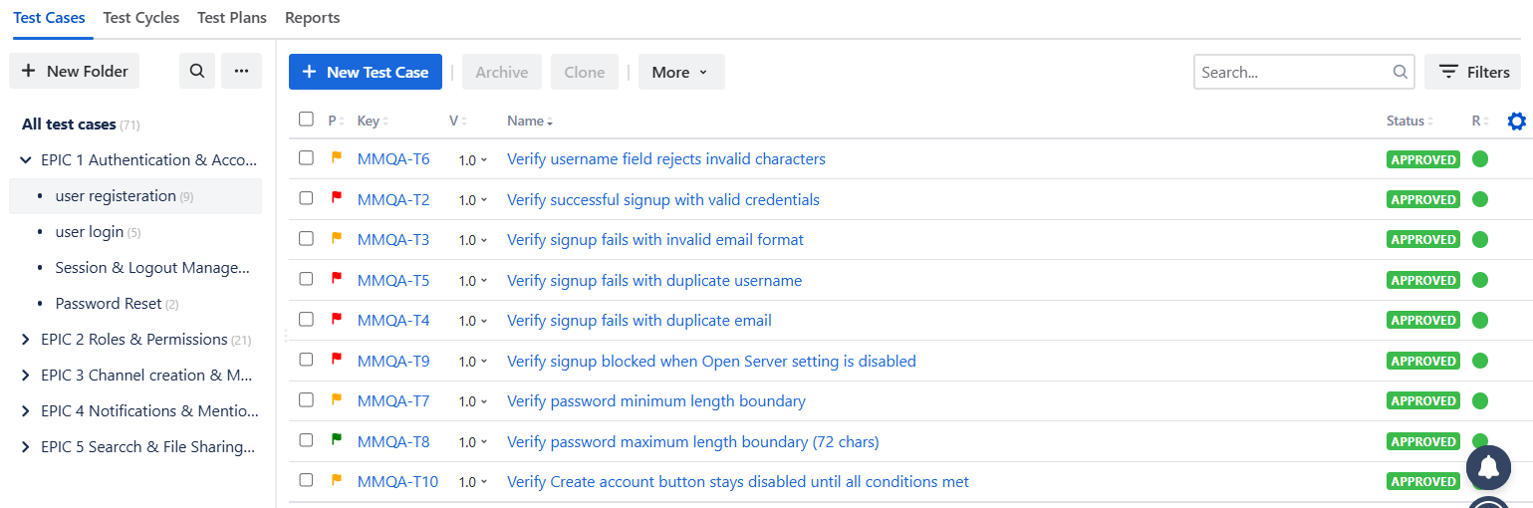

EPIC 1 - MMQA8 - USER LOGIN
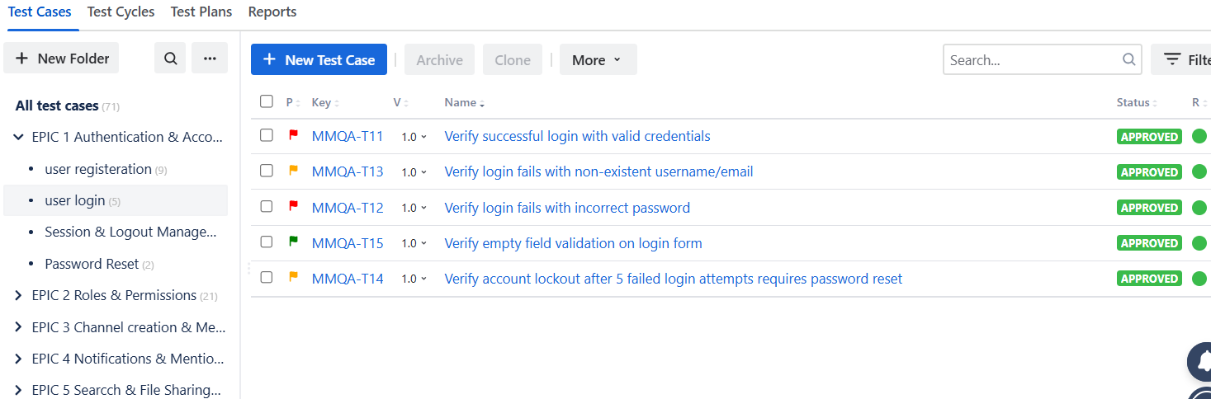

EPIC 1 - MMQA9 - SESSION & LOGOUT MANAGEMENT
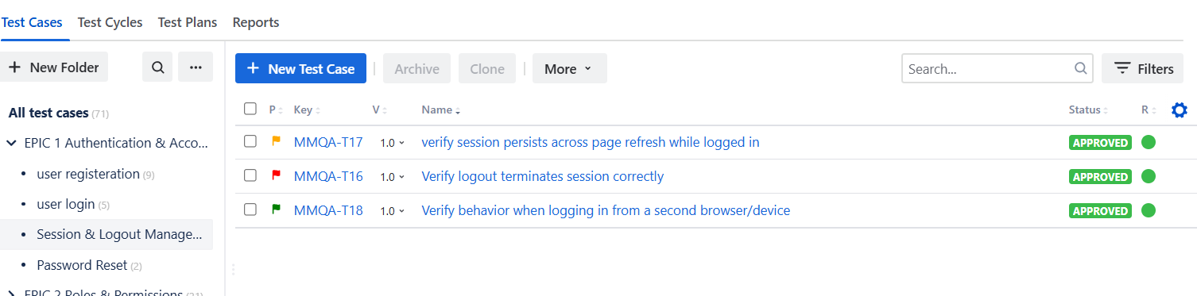
EPIC 1 - MMQA10 - PASSWORD RESET
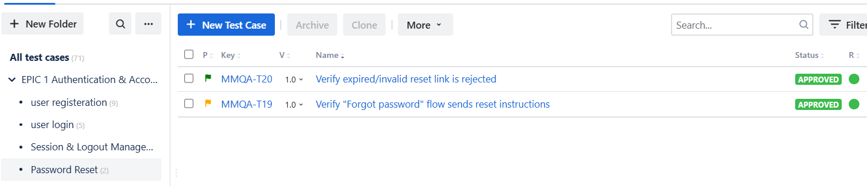

EPIC 2
EPIC 2 - MMQA11 - SYSTEM ADMIN CAPABILITIES
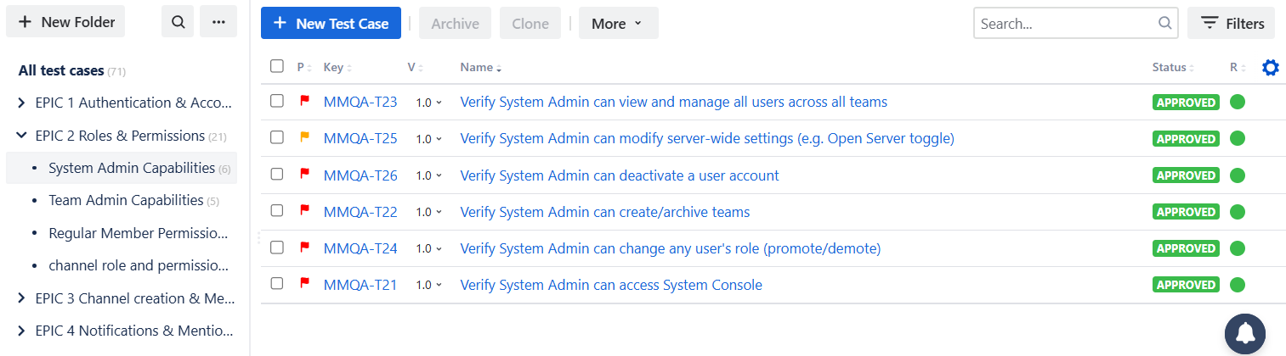

EPIC 2 - MMQA12 - TEAM ADMIN CAPABILITIES
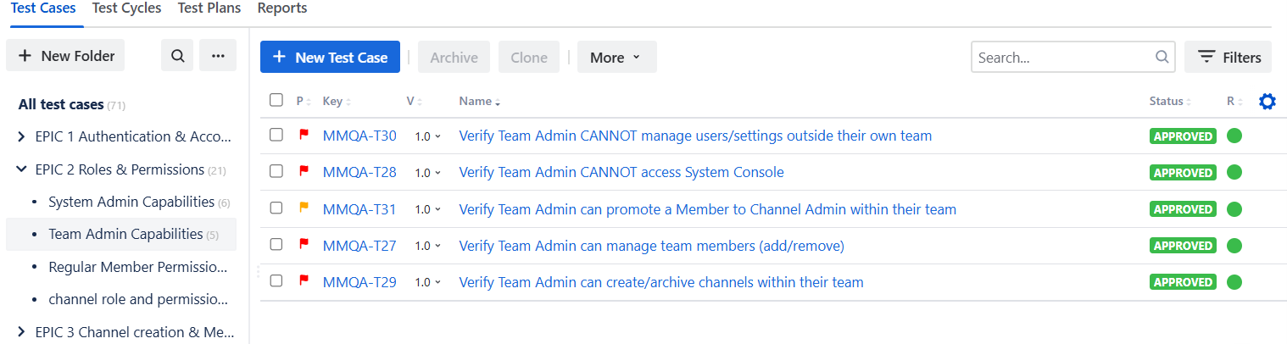

EPIC 2 - MMQA13 - REGULAR MEMBER PERMISSION
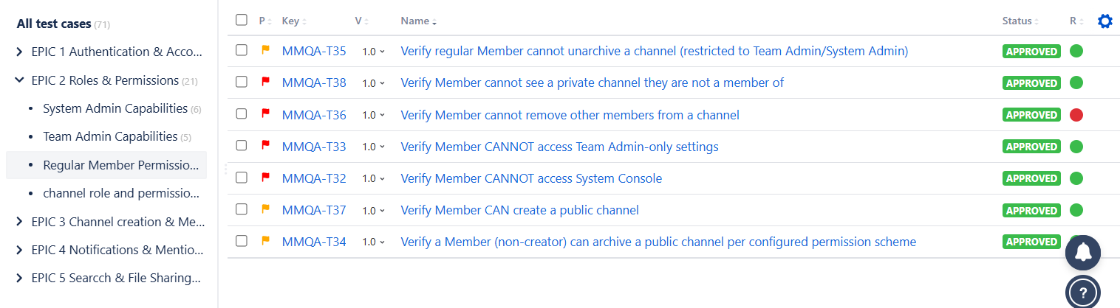

EPIC 2 - MMQA14 - CHANNEL ROLE AND PERMISSION
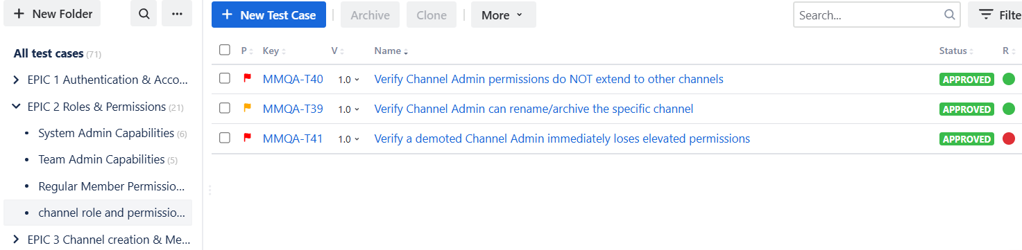

EPIC 3

EPIC 3 - MMQA15 - CHANNEL CREATION AND MANAGEMENT

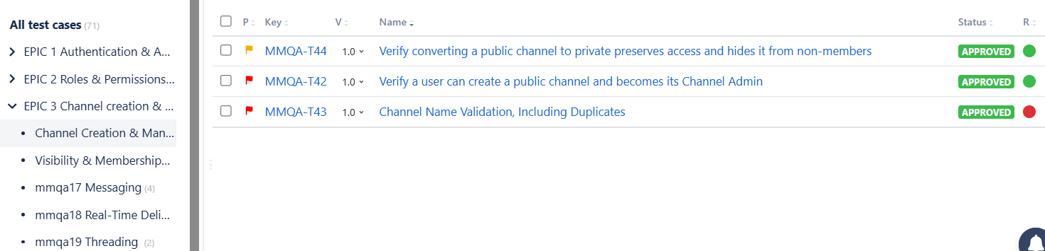

EPIC 3 - MMQA16 - VISIBILITY AND MANAGEMENT

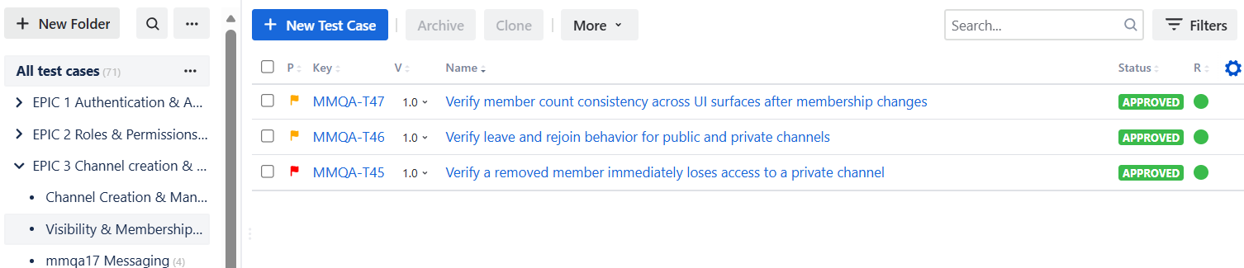

EPIC 3 - MMQA17 - MESSAGING

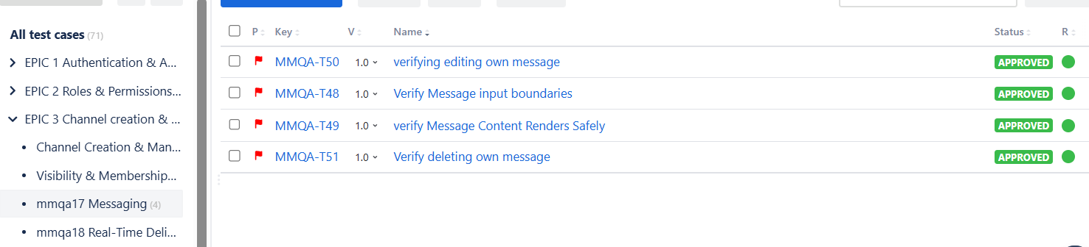

EPIC 3 - MMQA18 - REAL TIME DELIVERY
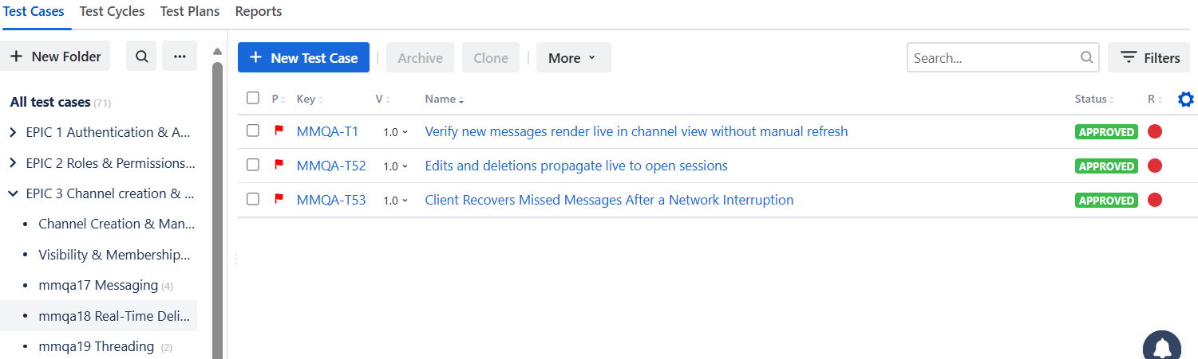

EPIC 3 - MMQA19 - THREADING
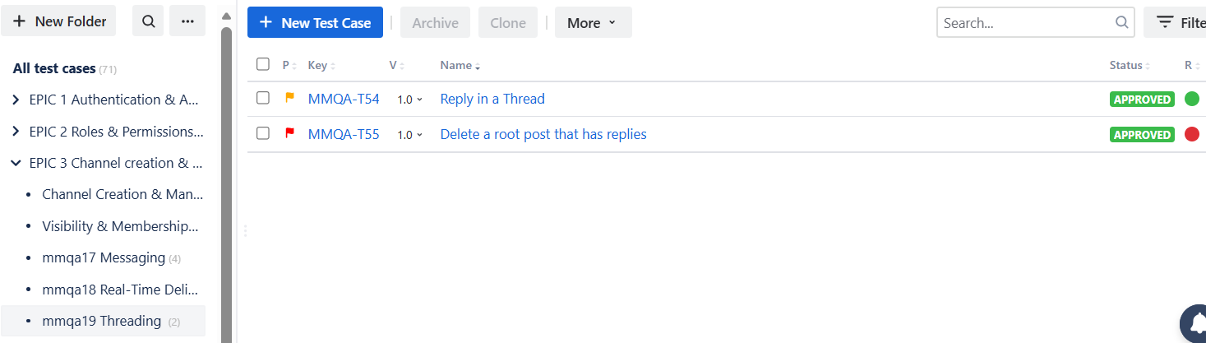

EPIC 4
EPIC 4 - MMQA20 - MENTION NOTIFICATION

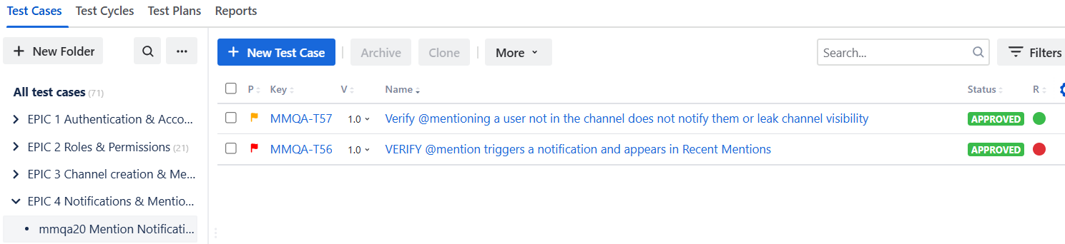
EPIC 4 - MMQA21 - CHANNEL WIDE MENTION
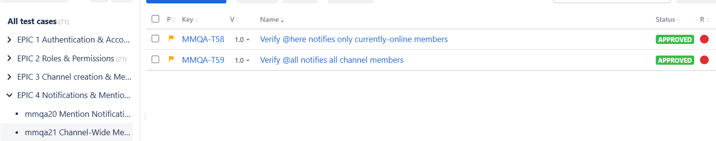
EPIC 4 - MMQA22 - NOTIFICATION PREFERENCES
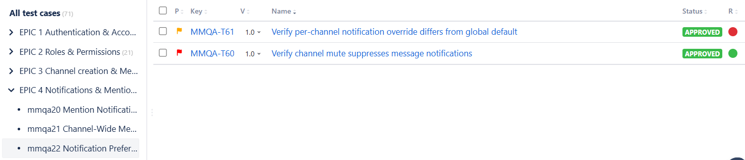

EPIC 4 - MMQA23 - UNREAD STATE

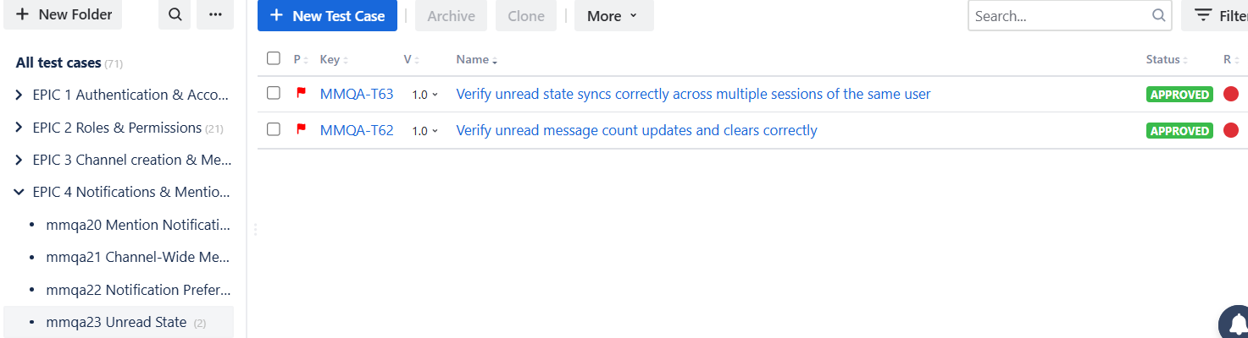

EPIC 5
EPIC 5 - MMQA24 - MESSAGE SEARCH

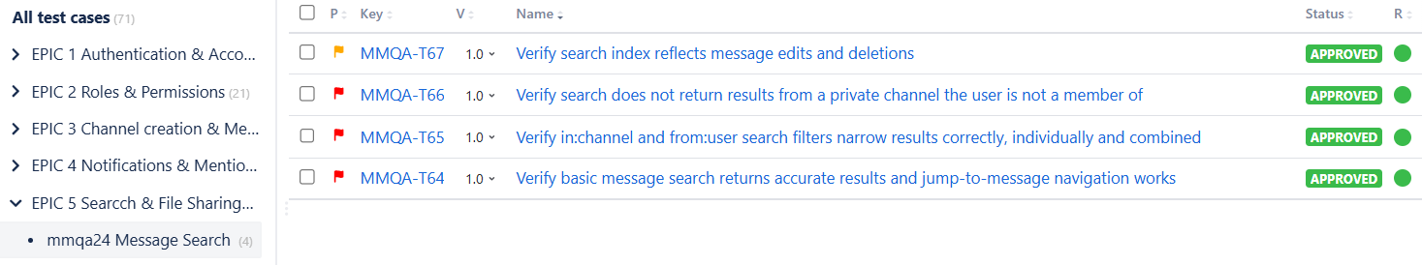
EPIC 5 - MMQA25 - FILE SHARING
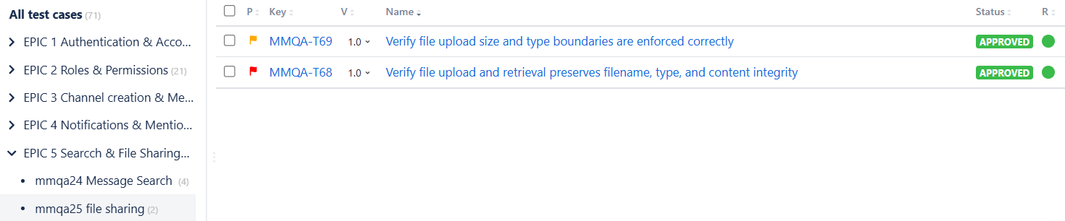

EPIC 5 - MMQA26 - FILE ACCESS PERMISSIONS
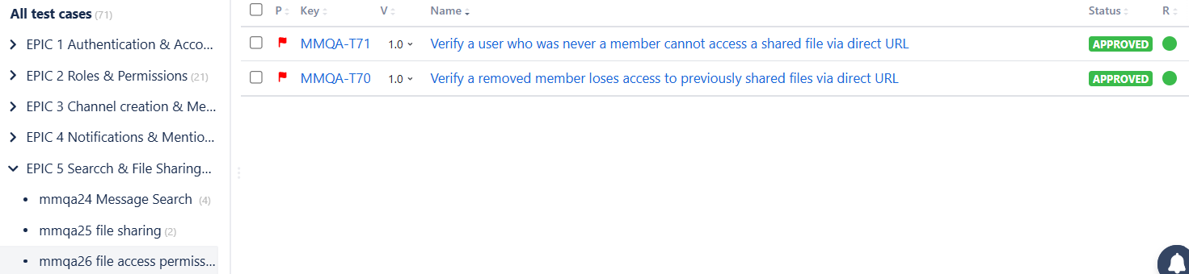

A DETAIL SCREENSHOTS OF A TEST CASE FROM ZEPHYR WITH ITS TEST SCRIPT, EXECUTION, TRACEABILITY AND DETAILS

- TEST CASE:
Verify new messages render live in chann... (MMQA-T1)

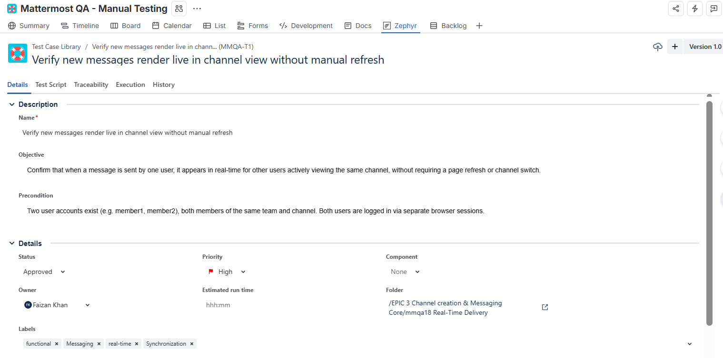

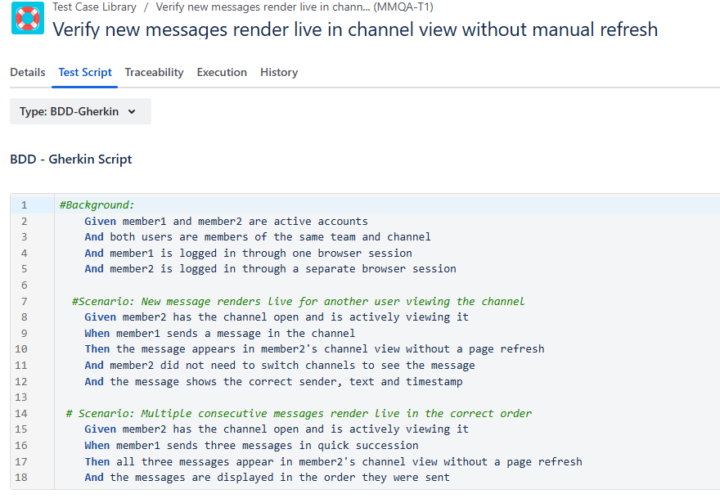

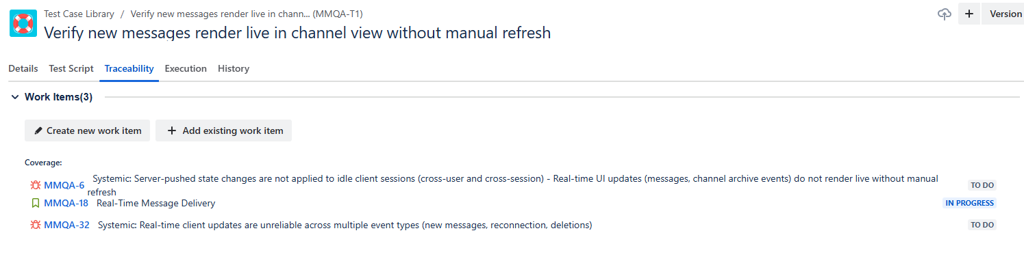

EXECUTION TAB:

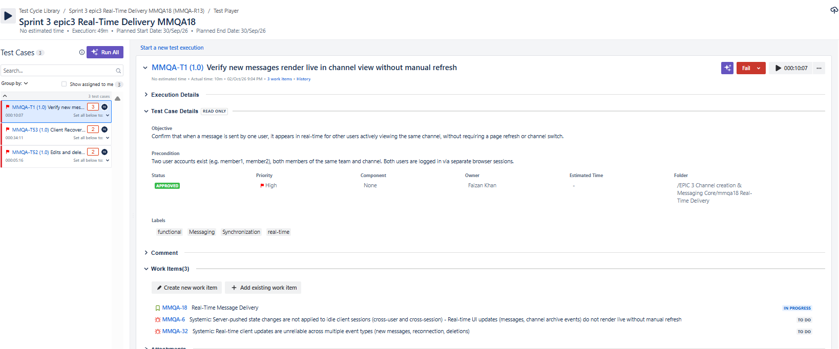

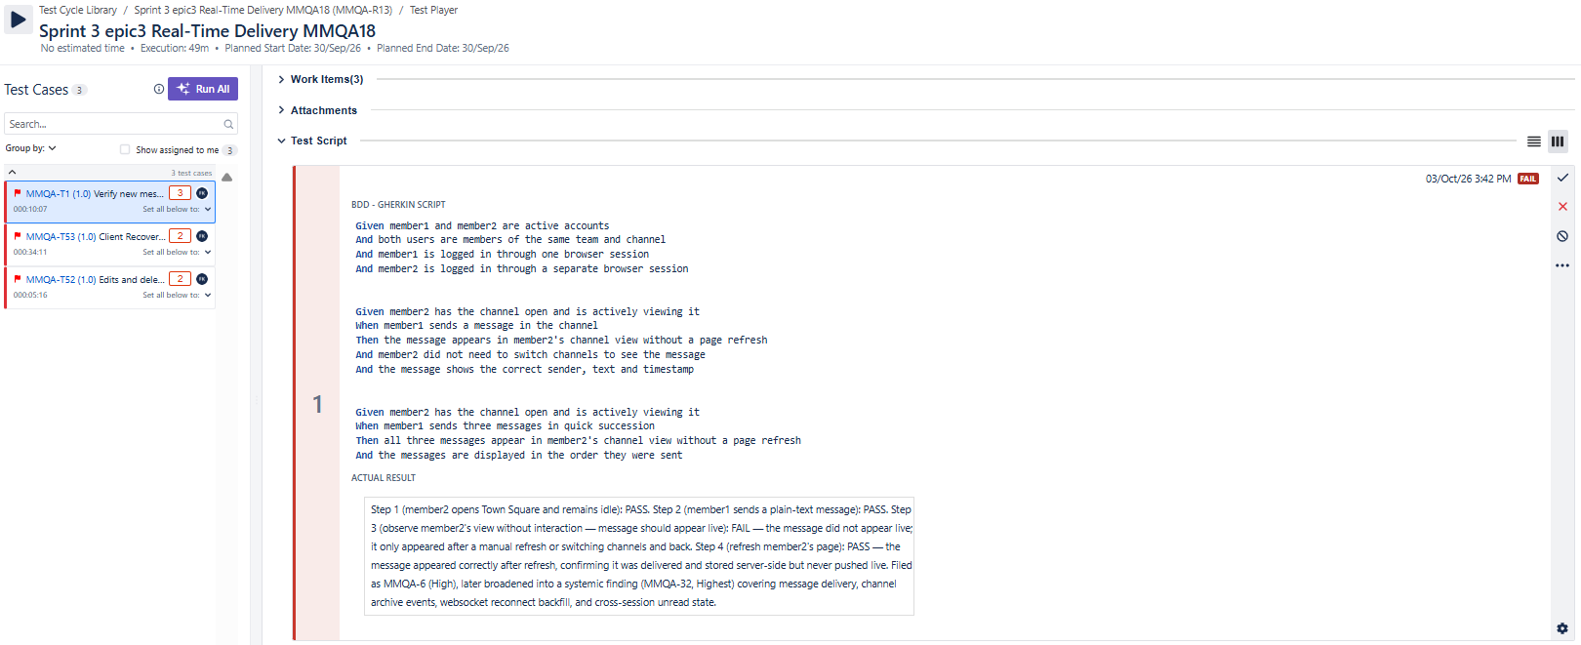

TEST CYCLE DETAILS OF SPRINT 3 ( ONLY RELATED TO MMQA-18 REAL TIME DELIVERY )



